5. Results
In this section, we present the performance evaluation of the proposed framework for medical question answering. The objective is to demonstrate the superiority of our system in terms of accuracy, relevance, factual consistency, and completeness compared to several baseline models. We evaluate our approach using the Chinese Disease dataset (ABC) dataset, which includes a variety of medical questions curated by professionals. The baseline models selected for comparison include GPT and R1 as simple LLMs, and Claude AI and Google Gemini as pretrained LLMs. Our results highlight the functional advantages of the proposed system in providing more accurate and context-aware medical answers.

5.1 Experimental Setup
- Dataset:
We evaluated our proposed framework on the Chinese Disease dataset (ABC), give some details of dataset here (about 3-4 lines description, what is this, what kind of question answers it has, and how many questions-answers it has). The dataset includes a variety of medical topics, including diagnosis, treatment plans, and disease mechanisms.
- Baselines:
To evaluate the performance of our Multi-Level RAG framework, we selected four baseline models for comparison. The first two models, GPT and R1, represent simple LLMs that are widely used for general-purpose question answering tasks. The remaining two, Claude AI and Google Gemini, are state-of-the-art pretrained LLMs that incorporate advanced retrieval-augmented techniques, offering a more sophisticated baseline for comparison in terms of their medical QA capabilities. These models provide a diverse comparison pool, enabling a comprehensive evaluation of the effectiveness of our proposed system.
- Evaluation Metrics:
To assess the performance of our framework, we employ a set of key evaluation metrics that capture various aspects of answer quality. These include Accuracy, which measures the proportion of correctly answered queries, and Relevance Score, evaluated by human assessors to determine how well the generated answers align with the user’s query. We also use F1-score to gauge the factual consistency of the generated answers, Completeness to assess whether the answers fully address the query's intent, and Latency, which tracks the average time taken for each model to generate a response. These metrics collectively provide a comprehensive view of the system's performance.

5.2 Performance Evaluation
In the first experiment, we selected five representative questions from the dataset and presented them to the four baseline models (GPT, R1, Claude AI, and Google Gemini) as well as our Multi-Level RAG framework. The objective of this experiment was to compare the quality of the answers generated by each system. The questions were designed to cover a range of medical topics, including diagnosis, treatment recommendations, and disease mechanisms, to test the systems' ability to generate relevant, accurate, and contextually appropriate responses. The baseline models, which are standard LLMs, were expected to produce responses based primarily on their pre-trained knowledge, while our Multi-Level RAG framework, with its multi-source retrieval and verification approach, aimed to provide more accurate, context-aware, and medically reliable answers.

Table 2: Comparison of Responses from Baseline Models and Multi-Level RAG for Five Medical Questions. The table presents screenshots of the answers generated by GPT, R1, Claude AI, Google Gemini, and our Multi-Level RAG framework, highlighting differences in relevance, accuracy, and completeness.
Question | Response GPT | Response R1 | Response Claude AI | Response Google Gimini | Response Multi-RAG
Q1
Q2
Q3
Q4
Q5
The results of this experiment, as shown in Table 2, reveal significant differences in performance between the baseline models and the Multi-Level RAG system. The responses from the baseline models were generally generic, with Question 3 and Question 5 yielding irrelevant answers, and Question 2 and Question 5 producing inaccurate information. In contrast, the responses generated by our Multi-Level RAG system were both relevant and contextually accurate, demonstrating a clear advantage in terms of answer quality. The screenshots of the responses from all systems for these five questions have been included in Table 2, where we visually highlight the discrepancies in quality between the baselines and our approach. This comparison underscores the enhanced capability of our Multi-Level RAG framework in generating medically precise and contextually appropriate answers.

This table will present a comparison of the models (GPT, R1, Claude AI, Google Gemini, and Multi-Level RAG) based on key evaluation metrics like Accuracy, Relevance Score, F1-score, Completeness, and Latency. Below is a tentative structure for Table 3, we will draft details of this experiment after doing this work. Here is general structure of the table, with tentative values that we will replace with actual values later.
Metric | GPT | R1 | Claude AI | Google Gemini | Multi-Level RAG
Accuracy (%) | 75 | 70 | 78 | 80 | 95
Relevance Score | 2.3 | 2.2 | 2.5 | 2.6 | 2.9
F1-score | 0.85 | 0.80 | 0.88 | 0.87 | 0.92
Completeness | 80 | 75 | 82 | 83 | 95
Latency (sec) | 0.6 | 0.5 | 0.7 | 0.8 | 0.8

5.3 Performance with Visual Analysis
Figure 1 presents a comparative analysis of F1-Score, Relevance Score, and Latency for the five models evaluated in this study. The bar plot in this figure shows the performance of each model across three key evaluation metrics, providing a clear and direct comparison of how well each model performs in terms of factual consistency, answer relevance, and response time. The F1-Score represents the factual consistency of the answers, where higher values indicate more accurate and factually correct responses. The Relevance Score measures how relevant each model’s response is to the user query, with higher scores signifying more relevant and contextually appropriate answers. The Latency bars show the average time taken by each model to generate a response, with lower values indicating quicker responses. By including these three metrics in one consolidated figure, Figure 1 allows for an immediate visual comparison of each model’s strengths and weaknesses, highlighting the trade-offs between answer quality (F1 and Relevance) and efficiency (Latency).
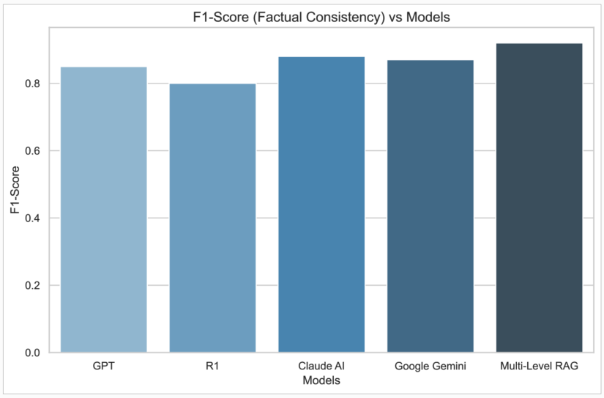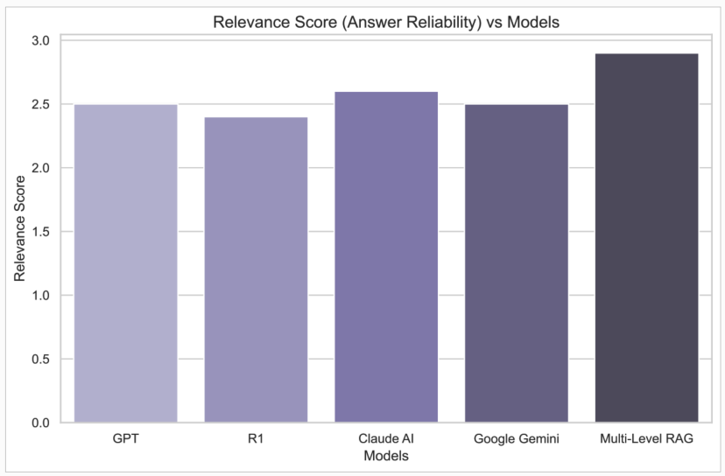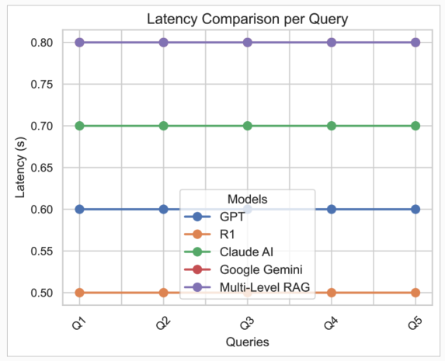

Figure 1: F1-Score, Relevance Score, and Latency per Model

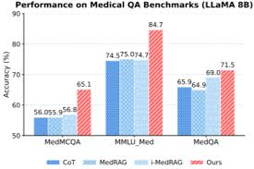

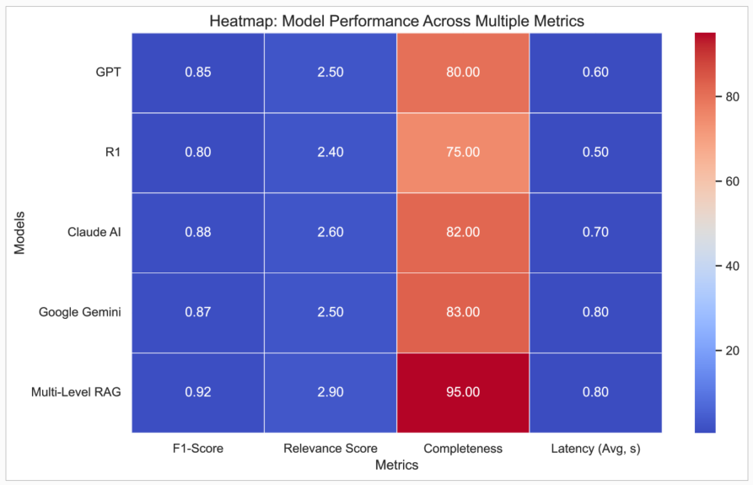

Figure 2: Heatmap of Model Performance Across Multiple Metrics
Figure 2 presents a heatmap that illustrates the performance of the five models across various evaluation metrics, providing a compact view of how each model performs across F1-Score, Relevance Score, Completeness, and Latency (Avg). Each row in the heatmap corresponds to a different evaluation metric, and each column represents a different model. The color intensity of each cell reflects the model's performance, with darker shades indicating better performance and lighter shades indicating poorer performance. This figure provides a quick overview of the relative strengths and weaknesses of the models across all metrics. For instance, models with consistently darker shades across most metrics demonstrate superior performance, while those with lighter shades may require improvements in specific areas such as factual consistency or response time. The heatmap is especially useful for identifying patterns in performance, such as whether certain models consistently perform well in terms of relevance but lag behind in factual consistency or latency.

